GEOL 551: Applied Petroleum Geology   
Assignment #5 - Due 3/11/2019

Nadima Dwihusna

**Notes for Homework:**

* Digitize more logs.

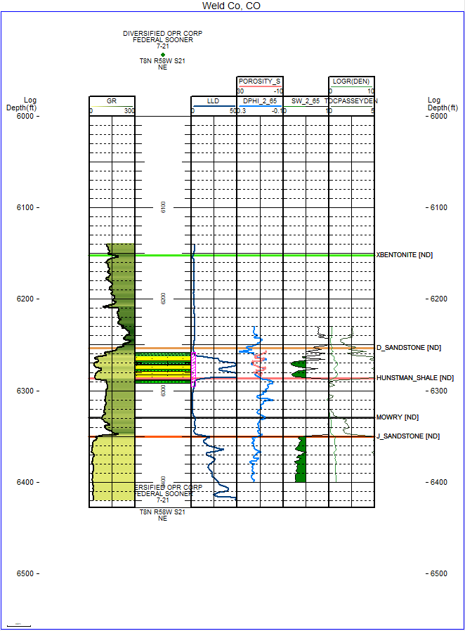

Figure 1. Example of Digitized Well Log

* DPHI 2_65 and SW 2_65 were calculated
* Oil in place equation:

OIP = 7758 * (So * Phi * H * A) / Bo

So = 1 - Sw

Bo = formation volume factor = approximately 1.5

* Other noted equations

LOG R(DEN)=LOG10(R/RBASE)-2.5*(RHOB-RHOBBASE)

Rbase = 1.5 and RHObase=2.5

TOC Density

TOC PASSEY DEN=(LOGR)*10**(2.297-(0.1688*LOM))

Youngs Modulus

YM=10000*RHO*(1/DTS)**2*(((3*(1/DTC)**2-4*(1/DTS)**2)/((1/DTC)**2-(1/DTS)**2)))

Poissons Ratio

PR=(1/2*(DTS/DTC)**2-1)/((DTS/DTC)**2-1)

Brittleness

BRITTLENESS=YM/PR

**Homework Task:**

1. **Updated the Volumetric Report**

As seen from the volumetric Report below, the estimated Oil In Place is 5,605.24 MBO and ROIP as 1,121.05 MBO for the gridded area. The formation volume factor is set to 1.5 and the recovery factor is 20%.

Volumetrics Report

PROJECT: SOONER FIELD - Weld Co, CO

March 8, 2019 4:23 PM

Grid File: D_SS_INTERVAL_NDSOPHIH.GRD

Title : D_SS_INTERVAL_ND - SOPHIH - Hydrocar Ft

XY Units : FEET

Z Units : FT

Volumes Computed Between 0 and 1E30

Minimum Thickness Allowed Is 0.000

Grid Refinement Is 1

Reservoir Parameters Used To Compute Recoverable Oil In Place (ROIP)

Formation Volume Factor (FVF)...: 1.5000

Recovery Factor (%).............: 20.00

Polygon: All Polygons Combined

Polygon Area: 2,818.66 (ACRES)

Data Area: 1,037.03 (ACRES)

OIP: 5,605.24 (MBO)

ROIP: 1,121.05 (MBO)

Polygon: ENTIRE GRID

Total Area: 2,818.66 (ACRES)

Data Area: 1,037.03 (ACRES)

OIP: 5,605.24 (MBO)

ROIP: 1,121.05 (MBO)

Definitions:

Total Area = Polygon Area

Data Area = Polygon Area covered by contours used in volumes

ROIP = HydrocarbonPoreVolume * Rf / FVF

Notes:

43560.0000 SqFt/Acre

4046.8490 SqMtr/Acre

7758.000000 BBL/AcFt

62.42796061 Convert G/CC to LBS/CUFT

Raw Area is SqFt

Raw Volume is SqFt x FT

DISCLAIMER:

Geoplus Corporation, IHS Inc, and its suppliers

do not and cannot warrant the performance

or results you may obtain by using this software, documentation, or

any accompanying hardware. Geoplus, IHS and its suppliers disclaim any

and all warranties, express or implied, as to merchantability or

fitness for any particular purpose. In no event will Geoplus, IHS or its

suppliers be liable to you or any third party for any consequential,

incidental, or special damages, including any lost profits or lost

savings, even if a Geoplus or IHS representative has been advised of the

possibility of such damages, or for any claim by any third party.

End of Report

1. **Sophih map**

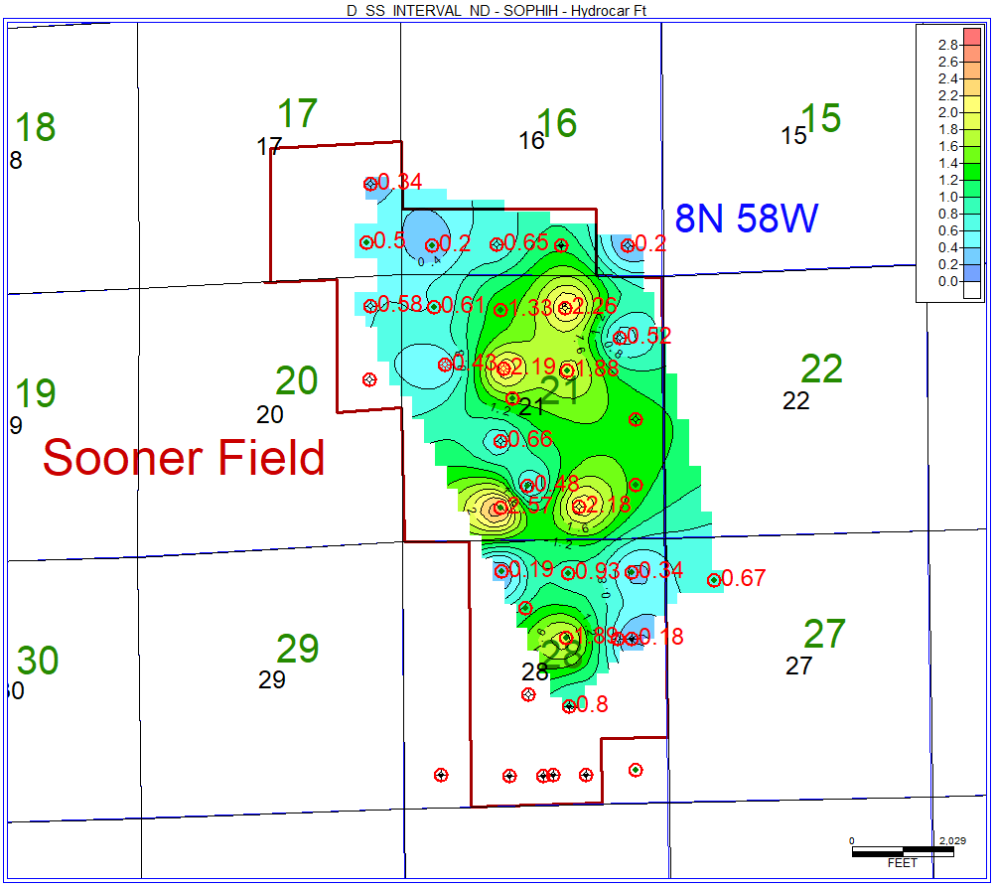

Figure 2: D SS Interval Isopach Map

1. **Demonstrate the steps and calculate the D SS Interval SOPHIH Hydrocarbon FT**

Computing from the logs and create the footages.

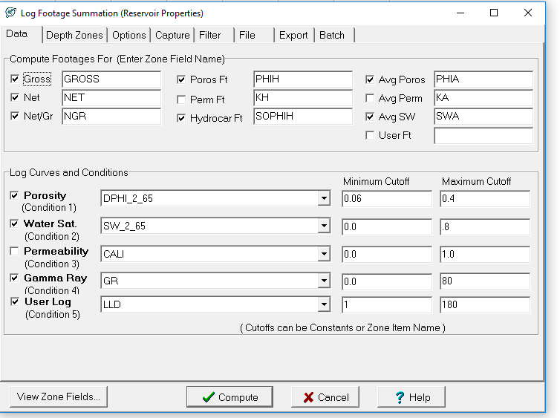

Choose D SS Interval

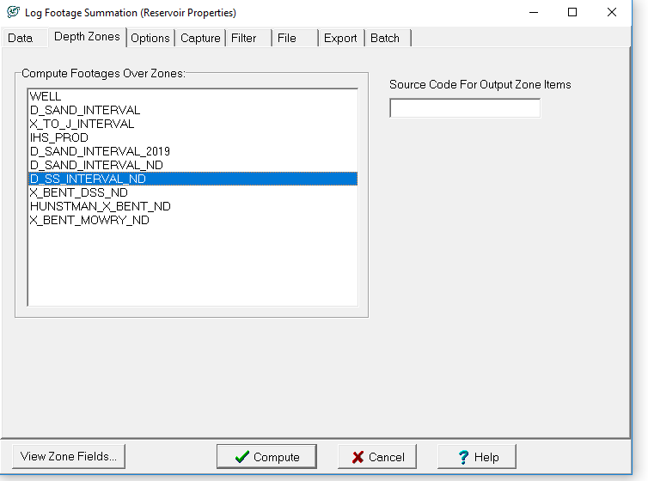

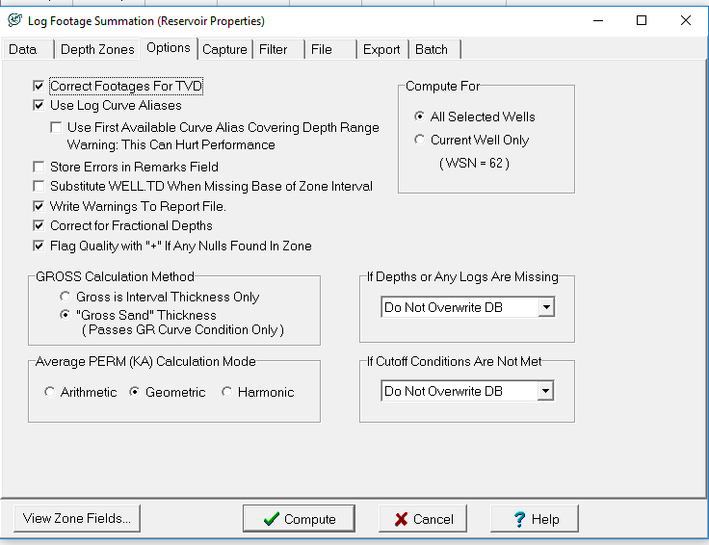

Now we have these

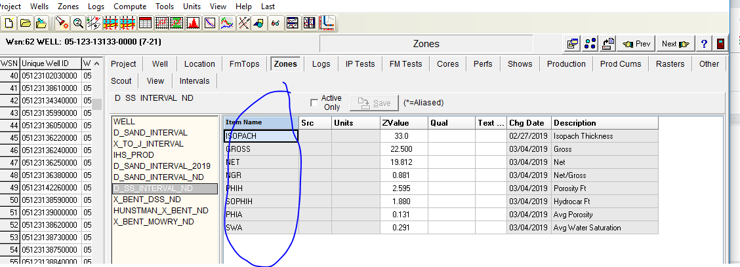

Now we can plot the contour of the sophih. Compute the volumetrics, compute volume from grid and data is ndsophih

